Competency Exploration for Development And Readiness (CEDAR)
Competency Assessment Tool

CEDAR is a dual-rater online competency assessment tool that uses supervisor and employee input to provide results that are employee-specific but can be aggregated up to component or agency levels for comprehensive analyses. It is intended to inform individual and organizational strategies to address skill gaps and support employee development, and it will not be used for employee performance ratings or hiring/promotion.
CEDAR uses OPM-approved competencies, competency models, and proficiency level rating options. There are no survey questions for either supervisors or employees to answer.

Competencies in the PMIAA Program Manager and Project Manager Competency Models
Note: Not all competencies will be in all competency models
Information about competencies, including definitions, can be found on OPM’s website (linked).

General Competencies
Accountability
Attention to Detail
Conflict Management
Creative Thinking
Customer Service
Decision Making
External Awareness
Flexibility
Influencing/Negotiating
Information Management
Integrity/Honesty
Interpersonal Skills
Leadership
Manages Human Resources
Manages Resources
Oral Communication
Organizational Awareness
Partnering
Planning and Evaluating
Political Savvy
Problem Solving
Reading Comprehension
Reasoning
Strategic Thinking
Teaching Others
Team Building
Teamwork
Technical Competence
Technical Credibility
Technology Application
Writing

Technical Competencies
Acquisition Strategy
Change Management
Compliance
Contracting/Procurement
Financial Management
Knowledge Management
Performance Measurement
Program Management
Project Management
Quality Management
Requirements Management
Risk Management
Schedule Management
Scope Management
Stakeholder Management

The assessment process uses a combination of the above competencies in a competency model (already loaded into the CEDAR tool) and proficiency level rating options. Below is screenshot example of a supervisor’s page where they are asked to provide their assessment of the employee. The supervisor is required to enter a targeted proficiency level rating and an employee’s current proficiency level rating for the assessment.
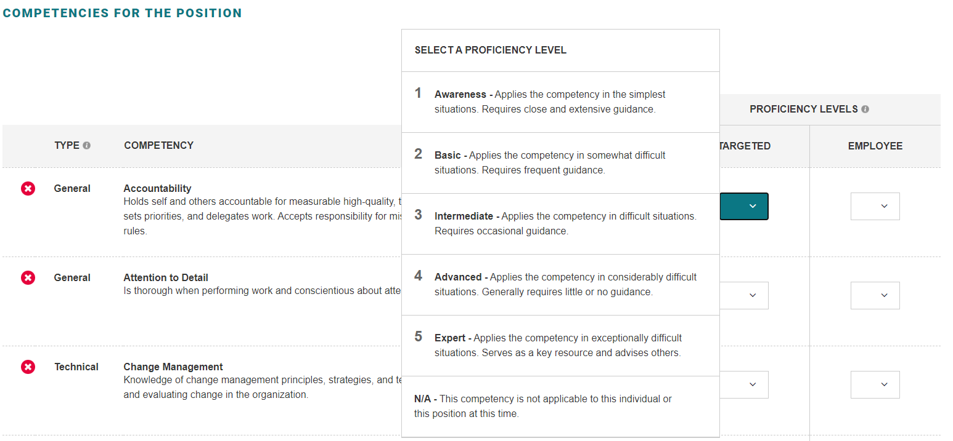

Proficiency level ratings and their definitions are available for each competency in both the targeted and employee columns. The “N/A” option was added to the proficiency level ratings options for the assessments based on feedback from multiple agencies. It encourages a supervisor to choose “N/A” instead of deleting a competency that they don’t think is relevant to a particular position. This is important for supervisors using competency models, such as those for the PMIAA.

Proficiency Level Ratings with Definitions

Value | Name | Type | Definition
1 | Awareness | General | • Applies the competency in the simplest situations  • Requires close and extensive guidance
2 | Basic | General | • Applies the competency in somewhat difficult situations  • Requires frequent guidance
3 | Intermediate | General | • Applies the competency in difficult situations  • Requires occasional guidance
4 | Advanced | General | • Applies the competency in considerably difficult situations  • Generally requires little or no guidance
5 | Expert | General | • Applies the competency in exceptionally difficult situations  • Serves as a key resource and advises others
Value | Name | Type | Definition
1 | Awareness | Technical | • Applies the competency in the simplest situations  • Requires close and extensive guidance  • Demonstrates awareness of concepts and processes
2 | Basic | Technical | • Applies the competency in somewhat difficult situations  • Requires frequent guidance  • Demonstrates familiarity with concepts and processes
3 | Intermediate | Technical | • Applies the competency in difficult situations  • Requires occasional guidance  • Demonstrates understanding of concepts and processes
4 | Advanced | Technical | • Applies the competency in considerably difficult situations  • Generally requires little or no guidance  • Demonstrates broad understanding of concepts and processes
5 | Expert | Technical | • Applies the competency in exceptionally difficult situations  • Serves as a key resource and advises others  • Demonstrates comprehensive, expert understanding of concepts and processes

N/A definition: “This competency is not applicable to this individual or this position at this time.”

Note: The above tables only include General and Technical competency type definitions. Leadership competencies have different definitions and include illustrations. However, there are no Leadership competencies in the PMIAA competency models, so that information is not included here.

After a supervisor has completed their assessment, the employee has an opportunity to choose up to three career growth competencies. This is optional. These can be any competencies, either from their position or from the list of competencies loaded into the CEDAR tool.

Once the employee goes through the career growth competency process, they are asked to provide a self-assessment of their current proficiency level by choosing a rating from the dropdown list next to each competency that is part of their assessment. The assessment page and process look similar to the supervisor’s page, except the employee only has their own self-assessment proficiency level rating to provide (no targeted proficiency level).

Once the supervisor’s and employee’s assessment information has been submitted, the CEDAR tool automatically calculates the results and provides all of the proficiency level ratings (targeted and employee) and the calculated difference. A negative difference for any given competency calculation indicates a gap in proficiency, while a positive difference shows a strength in proficiency. The results are printable for both supervisor and employee so that they can be used in discussions about targeted training and development opportunities.

