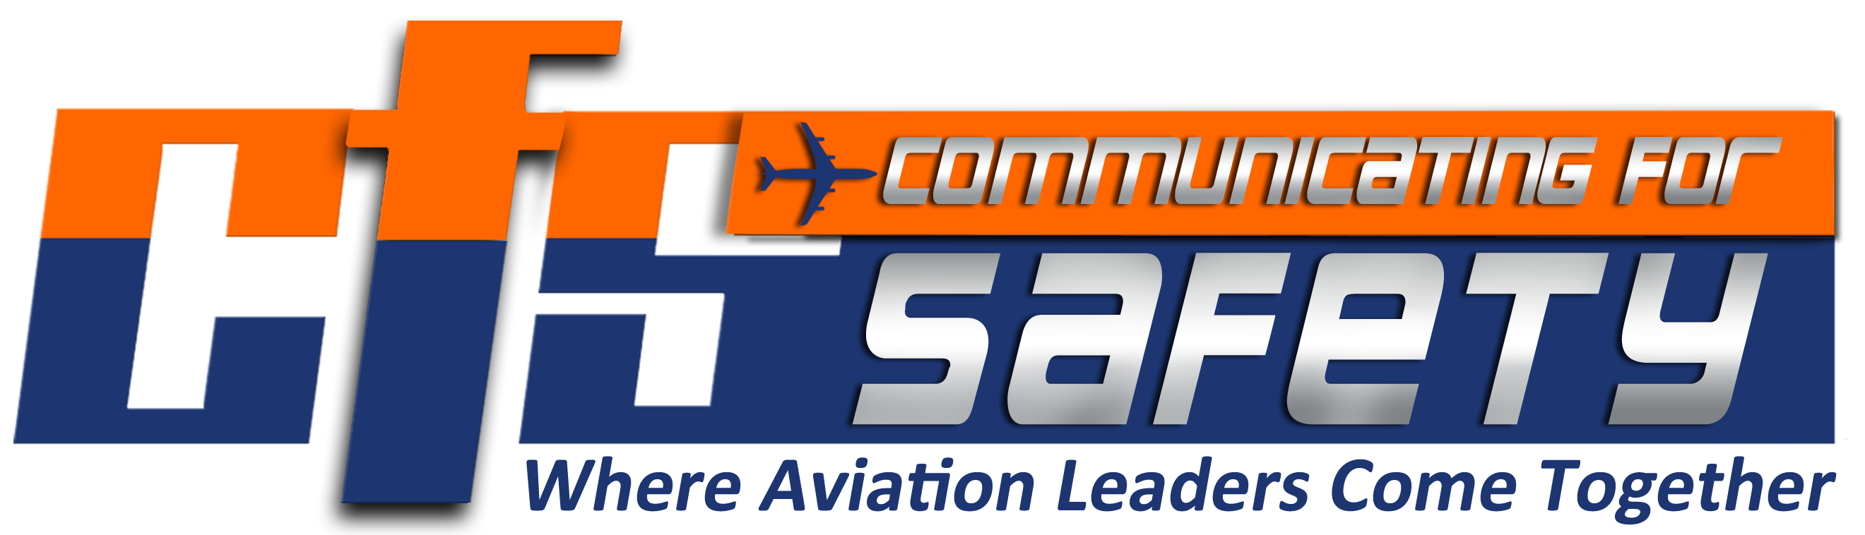
Date:

To: (Manger)

From: (You)

Re: Communicating for Safety 2023 (September 18-20, 2023)
Las Vegas, NV

This memorandum serves as a request for a release on excused absence in order to attend the 2023 Communicating for Safety Conference.

My request for release on excused absence includes the following dates: ___________________________. This request is made in accordance with (Choose One)

Article 29 Section 7 of the ATCS CBA
Article 29 Section 6 of the Consolidated CBA
Article 29 Section 6 of the Multi-Units CBA.

Sincerely,

Received By: _____________________________ Date: _________________

