TikTok, Guardians of the Sky Video Series, and Advocacy Videos Launch Plans

All approved vertical short-form videos will go on Tiktok, Reels (Instagram and Facebook), and YouTube Shorts.

Proposed Schedule:

Pre Launch
- Coordinate with Comm Comm members and other
NATCA members who have lots of TikTok followers
- Build out natca.org/saves landing page
  - Each video will have:
    - Thumbnail with title
    - Brief description
    - Link to full Archie League videos and story

NOTE: If Nick records a video during this schedule, we’d recommend sending it out as soon as it’s edited and pushing this schedule back by a day to accommodate it.

Day 1
- Introducing “Guardians of the Sky,” A New Video Series Highlighting America’s Extraordinary Air Traffic Controllers (video of ZBW’s Vermont National Guard save)
- Follow NATCA on Tiktok
Day 2
- Florida Air Traffic Controllers Help Passenger Land Plane After Their Pilot Is Incapacitated in NATCA’s Newest “Guardians of the Sky” Video
Day 3
- America’s Air Traffic Control Staffing Crisis: The Time to Act Is Now!
Day 4
- Sparks Fly as Plane Touches Down After Landing Gear MalFunction, LAX Air Traffic Controllers Save the Day in NATCA’s Newest “Guardians of the Sky” Video
Day 5
- NATCA: Modernize ATC Technology Now!
Day 6
- Anchorage Center Controllers Guide Coast Guard to Downed Aircraft in the Alaskan Wilderness in NATCA’s Newest “Guardians of the Sky” Video
Day 7
- NATCA: It’s Past Time to Modernize Air Traffic Control Facilities
Day 8
- Denver TRACON Controllers Help Southwest Plane With Missing Engine Cowling Land Safely in NATCA’s Newest “Guardians of the Sky” Video
Day 9
- Fort Worth Center Controllers Guide Plane With Low Fuel to Safety Despite Severe Oklahoma Storms in NATCA’s Newest “Guardians of the Sky” Video

**************************************************

- Introducing “Guardians of the Sky,” A New Video Series Highlighting America’s Extraordinary Air Traffic Controllers

Content for NATCA email, Facebook, LinkedIn, Instagram:

NATCA is launching a new video series called “Guardians of the Sky.” Each video will highlight a real-life incident where America’s air traffic controllers exemplified their skill, training, and professionalism in a moment of crisis.

Controllers do amazing work every day to ensure flying remains one of the safest and most efficient modes of transportation in the world. These Guardians of the Sky videos emphasize the dedication of these incredibly well-trained, hard-working men and women and the responsibility they demonstrate every day to the safety of the American flying public.

Our first video spotlights the incredible work of several air traffic controllers at Boston Center (ZBW) who stepped up to assist a military pilot of a F-16 trying to find a safe place to land in blizzard weather conditions while running low on fuel.

#Unions #Labor #LaborUnions #UnionStrong #aviation #ATC #NATCAStrong #AirTrafficControllers #NATCA #NATCAproud #weguideyouhome #strongertogether #solidarity

Content for NATCA website:

NATCA is launching a new video series called “Guardians of the Sky.” Each video highlights a real-life incident where America’s air traffic controllers exemplified their skill, training, and professionalism in a moment of crisis.

Controllers do amazing work every day to ensure flying remains one of the safest and most efficient modes of transportation in the world. Guardians of the Sky emphasizes our dedication to this profession and the responsibility we have to the flying public.

Our first video spotlights the incredible work of several air traffic controllers at Boston Center (ZBW) who stepped up to assist a military pilot of a F-16 trying to find a safe place to land in blizzard weather conditions while running low on fuel.

Watch the video here: <link to Reel>

Short Form for Twitter:

NATCA is now on TikTok! Follow us @natcanational and check out our first video that spotlights the incredible work of air traffic controllers at Boston Center who stepped up to assist a military pilot trying to find a safe place to land in a blizzard while running low on fuel.<link to full story on natca.org, content above>

Caption for TikTok, YouTube:

Controllers do amazing work every day to ensure flying remains one of the safest and most efficient modes of transportation in the world. Our new series, Guardians of the Sky, emphasizes our dedication to this profession and the responsibility we have to the flying public.

This video spotlights the incredible work of several air traffic controllers at Boston Center (ZBW) who stepped up to assist a military pilot of a F-16 trying to find a safe place to land in blizzard weather conditions while running low on fuel.

#aviation #flying #airplanes #ATC #ATCOS #AirTrafficControllers #NATCA #weguideyouhome #solidarity #Unions #Labor #LaborUnions #UnionStrong #fyp #federalworkers

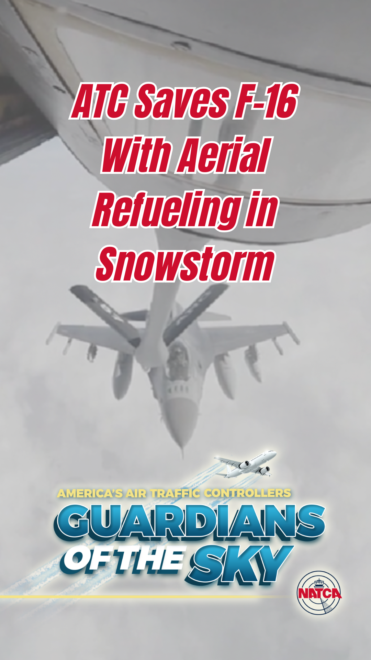

Website tags: Archie League Medal of Safety Awards, Guardians of the Sky, TikTok

**************************************************

- Follow NATCA on Tiktok

Content for NATCA email, Facebook, LinkedIn, Instagram, and NATCA Website:

NATCA is now on TikTok! Our Union is launching its TikTok with videos that highlight the incredible work of air traffic controllers; discuss advocacy issues important to air traffic controllers, other aviation safety professionals, and the aviation community; messages from NATCA leaders; and highlights from NATCA events. If you are on TikTok, please follow us @natcanational today!

Short Form for Twitter:

#NATCA is launching its TikTok w/ videos that highlight the incredible work of air traffic controllers, discuss issues important to controllers & the aviation community, messages from NATCA leaders, present highlights from NATCA events. Follow us @natcanational today!

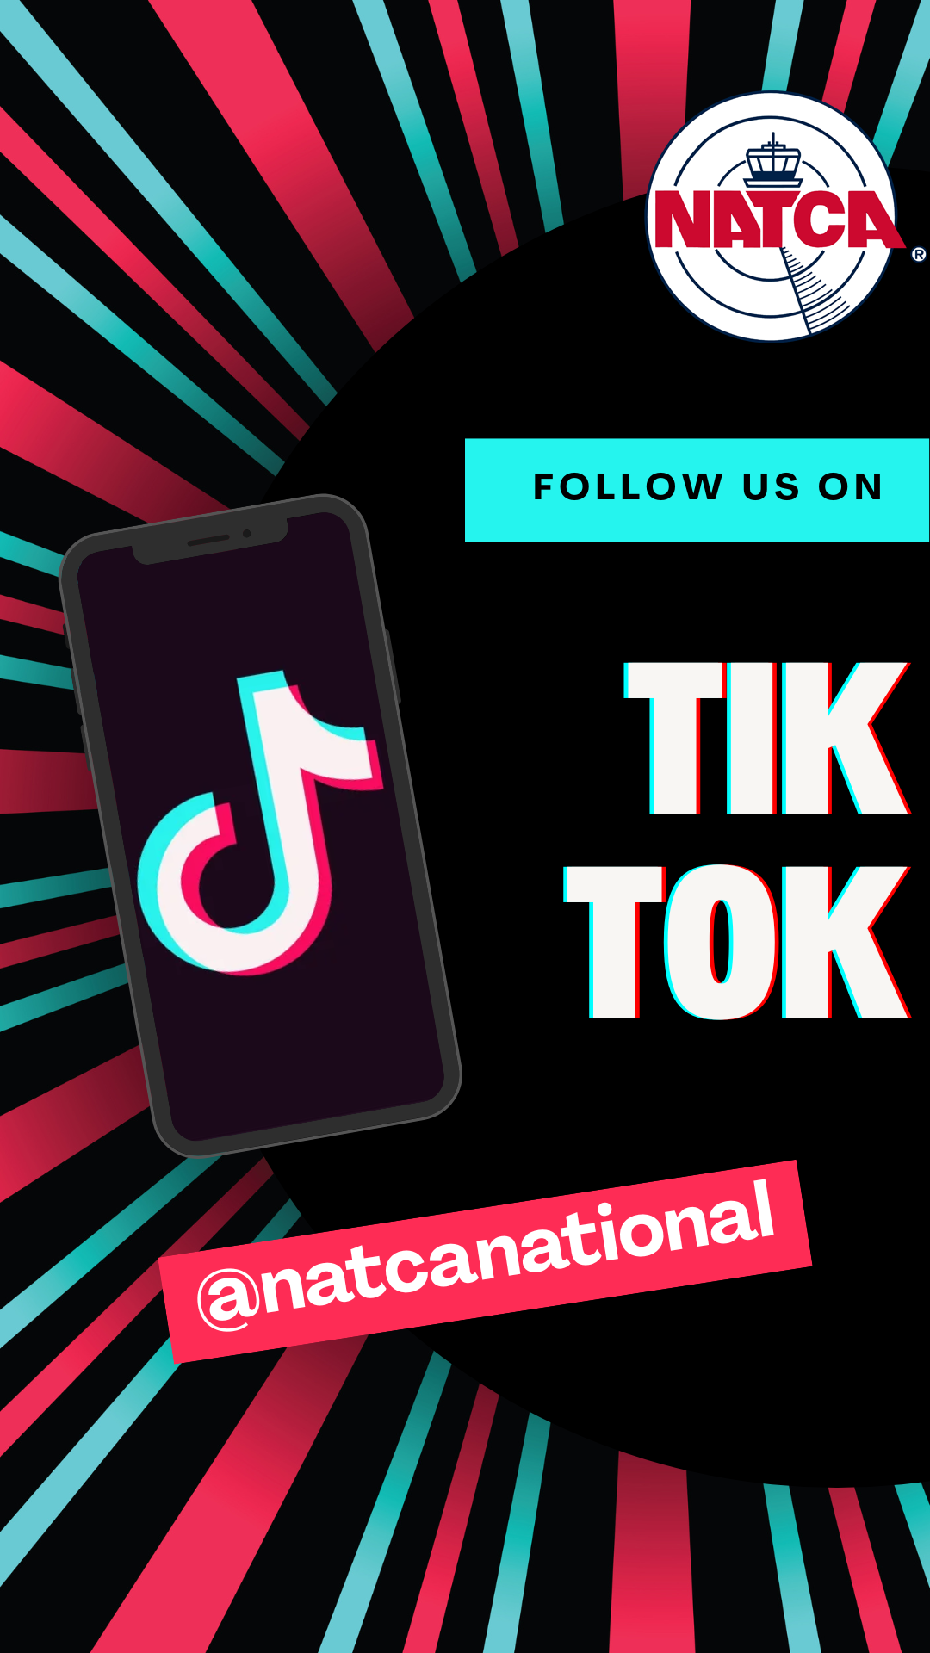

Website tags: TikTok

**************************************************

- Florida Air Traffic Controllers Help Passenger Land Plane After Their Pilot is Incapacitated in New “Guardians of the Sky” Video

Content for NATCA email, Facebook, LinkedIn, Instagram:

NATCA is now on Tiktok! Follow us @natcanational. Our latest video spotlights the truly amazing work of several air traffic controllers at Fort Pierce ATCT (FPR) and Palm Beach International ATCT (PBI) who helped a passenger who didn’t know how to fly land a plane safely after their pilot became incapacitated because of a medical emergency.

Controllers do amazing work every day to ensure flying remains one of the safest and most efficient modes of transportation in the world. Guardians of the Sky emphasizes our dedication to this profession and the responsibility we have to the flying public.

#Unions #Labor #LaborUnions #UnionStrong #aviation #ATC #NATCAStrong #AirTrafficControllers #NATCA #NATCAproud #weguideyouhome #strongertogether #solidarity

Content for NATCA website:

NATCA just launched a new video series called “Guardians of the Sky.” Each video highlights a real-life incident where America’s air traffic controllers exemplified their skill, training, and professionalism in a moment of crisis.

In our latest installment, NATCA highlights air traffic controllers from Florida who helped a passenger who didn’t know how to fly land a plane safely after their pilot became incapacitated because of a medical emergency.

Watch the video here: <link to Reel>

Short Form for Twitter:

NATCA is now on Tiktok! Follow us @natcanational. Our latest video highlights controllers who helped a passenger who didn’t know how to fly land a plane safely after their pilot became incapacitated because of a medical emergency. <link to full story on natca.org, content above>

Caption for TikTok, YouTube:

After the pilot experienced a medical emergency mid-flight, air traffic controllers from Fort Pierce ATCT and Palm Beach ATCT helped guide a passenger with no flying experience to pilot the plane and make a safe landing.

Air traffic controllers do amazing work every day to ensure flying remains one of the safest and most efficient modes of transportation in the world. These Guardians of the Sky videos emphasize the dedication of these incredibly well-trained, hard-working men and women and the responsibility they demonstrate every day to the safety of the American flying public.

#aviation #flying #airplanes #ATC #ATCOS #AirTrafficControllers #NATCA #weguideyouhome #solidarity #Unions #Labor #LaborUnions #UnionStrong #fyp #federalworkers

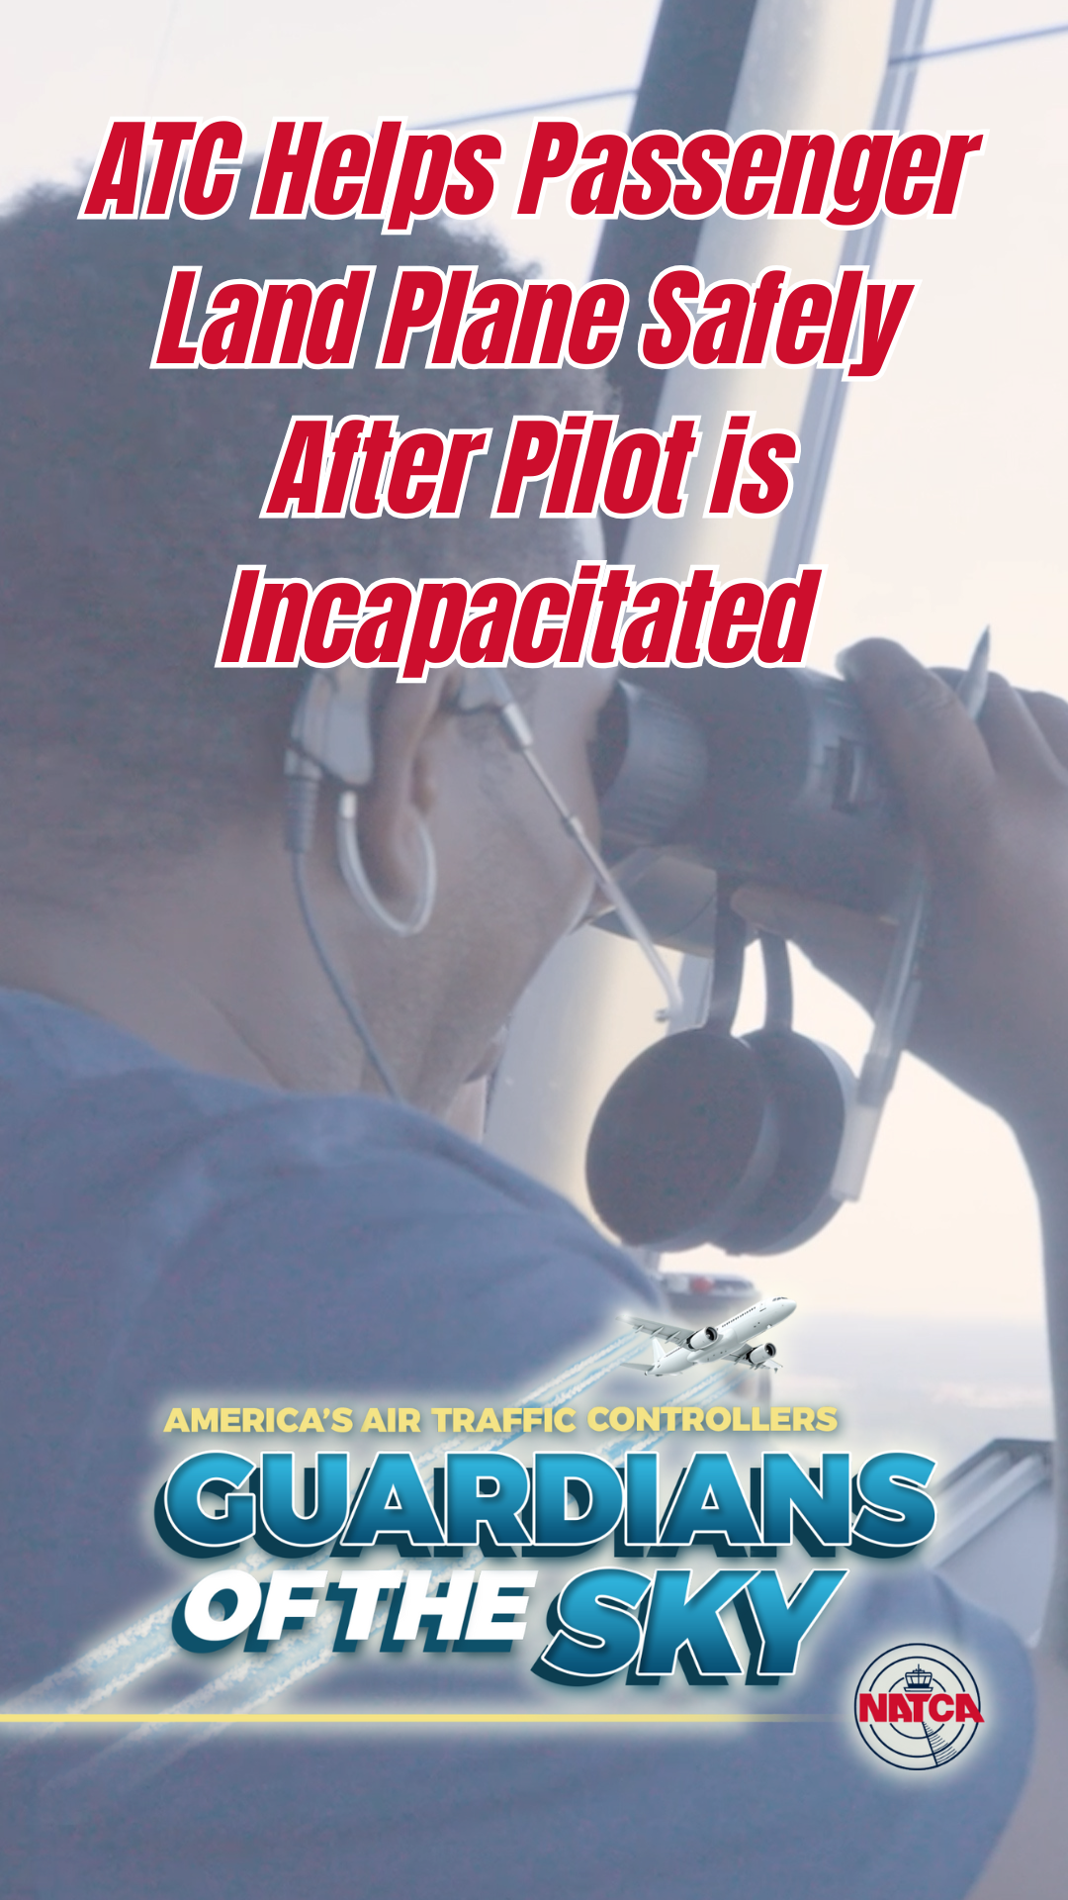

Website tags: Archie League Medal of Safety Awards, Guardians of the Sky, TikTok

**************************************************

- America’s Air Traffic Control Staffing Crisis: The Time to Act Is Now!

Content for NATCA email, Facebook, LinkedIn, Instagram:
We need 3,800 more certified air traffic controllers to ensure the safety and efficiency of our national airspace. Right now, controllers are working exhausting schedules — 10-hour shifts, 6 days a week, with just 4 days off a month.
This video breaks down what’s at stake and why NATCA proudly supports DOT Secretary Sean Duffy’s plan to hire and train more controllers.
But this solution requires action — Congress must fully fund the plan.
Watch and share to support supercharging controller hiring.
#Unions #Labor #LaborUnions #UnionStrong #aviation #ATC #NATCAStrong #AirTrafficControllers #NATCA #NATCAproud #weguideyouhome #strongertogether #solidarity

Content for NATCA website:
America is facing a critical air traffic controller staffing crisis — and the consequences affect every traveler, every airline, and every corner of our national airspace.
To safely and effectively operate our air traffic control (ATC) system, the United States needs 3,800 more certified controllers. Today’s dedicated controllers are doing everything they can to keep the skies safe — often working 10-hour shifts, 6 days a week, with as few as four days off a month. It’s unsustainable and dangerous.
For over a decade, the National Air Traffic Controllers Association (NATCA) has been sounding the alarm. The staffing shortfall is not a future problem — it’s a crisis happening right now.
That’s why NATCA proudly supports U.S. Department of Transportation Secretary Sean Duffy’s new plan to supercharge controller hiring and finally bring staffing levels to where they need to be. It’s a bold step — but to succeed, the plan requires full funding from Congress.
We must act now. Investing in the workforce behind our ATC system is investing in the safety, reliability, and future of American aviation.
Let’s give this country the air traffic control system it deserves — and can be proud of.
Watch the video here: <link to Reel>

Short Form for Twitter:

NATCA is now on Tiktok! Follow us @natcanational. Our latest video highlights why America needs 3,800 more air traffic controllers to keep our skies safe. NATCA supports @SecDuffy and his plan to fix the crisis. Congress must fully fund it. <link to full story on natca.org, content above>

Caption for TikTok, YouTube:
America needs 3,800 more air traffic controllers to keep our skies safe.
They’re working 10-hour days, 6 days a week — with just 4 days off a month.
NATCA supports Sec. Sean Duffy’s plan to fix the crisis.
Congress must fully fund it.
#aviation #flying #airplanes #ATC #ATCOS #AirTrafficControllers #NATCA #weguideyouhome #solidarity #Unions #Labor #LaborUnions #UnionStrong #fyp #federalworkers

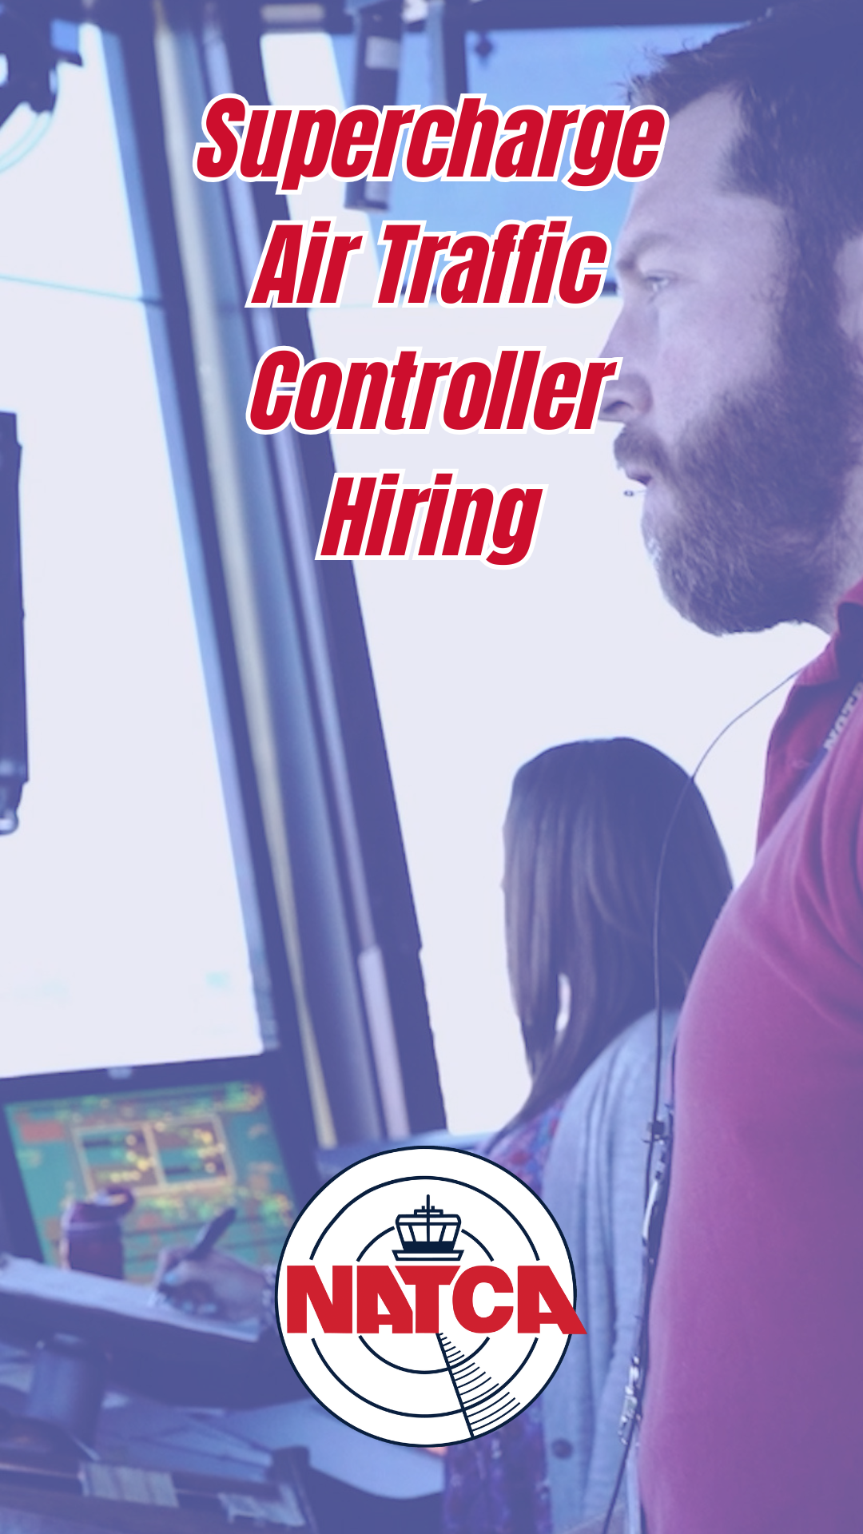

Website tags: Staffing, TikTok

**************************************************

- Sparks Fly as Plane Touches Down After Landing Gear MalFunction, LAX Air Traffic Controllers Save the Day in New “Guardians of the Sky” Video

Content for NATCA email, Facebook, LinkedIn, Instagram:

NATCA is now on Tiktok! Follow us @natcanational. Our latest video spotlights the work of several air traffic controllers at Los Angeles ATCT (LAX) who arranged for emergency personnel to be ready when a FedEx plane made an emergency landing at the airport after their landing gear malfunctioned.

Controllers do amazing work every day to ensure flying remains one of the safest and most efficient modes of transportation in the world. Guardians of the Sky emphasizes our dedication to this profession and the responsibility we have to the flying public.

#Unions #Labor #LaborUnions #UnionStrong #aviation #ATC #NATCAStrong #AirTrafficControllers #NATCA #NATCAproud #weguideyouhome #strongertogether #solidarity

Content for NATCA website:

NATCA just launched a new video series called “Guardians of the Sky.” Each video highlights a real-life incident where America’s air traffic controllers exemplified their skill, training, and professionalism in a moment of crisis.

In our latest installment, NATCA highlights the work of several air traffic controllers at Los Angeles ATCT (LAX) who arranged for emergency personnel to be ready when a FedEx plane made an emergency landing at the airport after their landing gear malfunctioned.

Watch the video here: <link to Reel>

Short Form for Twitter:

NATCA is now on Tiktok! Follow us @natcanational. Our latest video highlights controllers at LAX who helped a plane make an emergency landing at the airport after their landing gear malfunctioned.<link to full story on natca.org, content above>

Caption for TikTok, YouTube:

After the plane’s landing gear malfunctioned, air traffic controllers from Los Angeles ATCT (LAX) arranged for emergency personnel to be ready when a FedEx plane made an emergency landing at the airport.

Air traffic controllers do amazing work every day to ensure flying remains one of the safest and most efficient modes of transportation in the world. These Guardians of the Sky videos emphasize the dedication of these incredibly well-trained, hard-working men and women and the responsibility they demonstrate every day to the safety of the American flying public.

#aviation #flying #airplanes #ATC #ATCOS #AirTrafficControllers #NATCA #weguideyouhome #solidarity #Unions #Labor #LaborUnions #UnionStrong #fyp #federalworkers

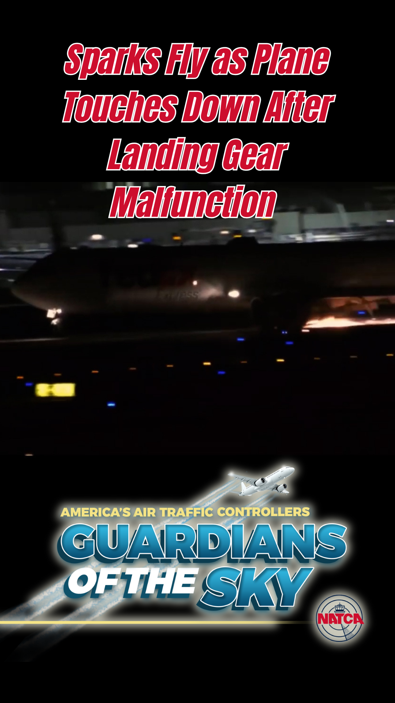

Website tags: Archie League Medal of Safety Awards, Guardians of the Sky, TikTok

**************************************************
- NATCA: Modernize ATC Technology Now!
Content for NATCA email, Facebook, LinkedIn, Instagram:

Every day, our air traffic control (ATC) system moves over 50,000 flights — but it still relies on paper strips from the 1960s, floppy disks, and copper wire communication systems.
These outdated technologies are causing outages, delays, and growing safety risks. America’s flying public and the air traffic controllers who guide them deserve better.
NATCA proudly supports DOT Secretary Sean Duffy’s plan to modernize the ATC system — but Congress must fully fund it.
Watch the video and help us bring the National Airspace System into the 21st century.
#Unions #Labor #LaborUnions #UnionStrong #aviation #ATC #NATCAStrong #AirTrafficControllers #NATCA #NATCAproud #weguideyouhome #strongertogether #solidarity

Content for NATCA website:

Every day, America’s air traffic controllers safely guide more than 50,000 flights through the National Airspace System. They manage one of the most complex aviation systems in the world — but they’re doing it with outdated technology.
Many air traffic control (ATC) facilities are still using paper flight progress strips, a method that dates back to the 1960s. Some FAA systems rely on floppy disks to upload critical data. Communications and radar signals are transmitted through aging copper wire infrastructure. These obsolete systems lead to frequent outages, flight delays, and growing risks to the safety and efficiency of air travel.
The National Air Traffic Controllers Association (NATCA) is proud to support U.S. Department of Transportation Secretary Sean Duffy’s plan to fully modernize America’s air traffic control system. This plan will replace outdated tools with modern, digital, and resilient technologies — ensuring safety, reliability, and efficiency for generations to come.
But modernization takes resources. Congress must fully fund Secretary Duffy’s plan to bring our air traffic control system into the 21st century.
America’s flying public deserves better. America’s air traffic controllers deserve better.
Let’s give this country the air traffic control system it deserves — and can be proud of.
Watch the video here: <link to Reel>

Short Form for Twitter:

NATCA is now on Tiktok! Follow us @natcanational. America’s ATC still uses paper strips, floppy disks & copper wire. Over 50,000 flights a day rely on this aging system. NATCA backs @SecDuffy’s plan to modernize ATC systems. <link to full story on natca.org, content above>

Caption for TikTok, YouTube:

50,000+ flights a day and controllers still use paper strips. Outdated tech leads to delays and outages. NATCA supports Sec. Sean Duffy’s plan to modernize ATC. Congress must fund it.
#aviation #flying #airplanes #ATC #ATCOS #AirTrafficControllers #NATCA #weguideyouhome #solidarity #Unions #Labor #LaborUnions #UnionStrong #fyp #federalworkers

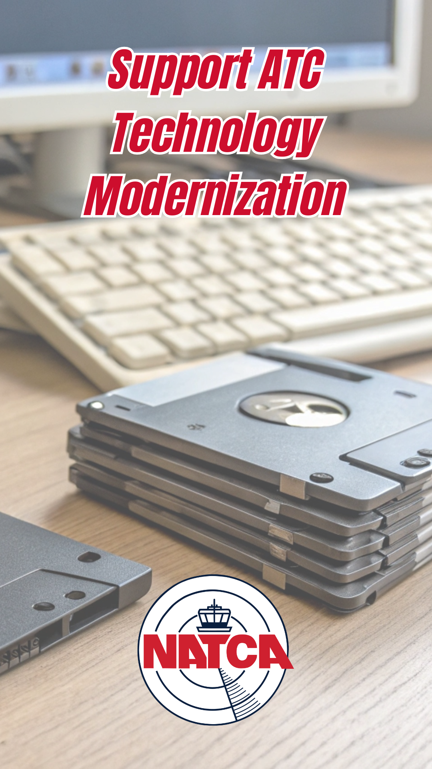

Website tags: Modernization, TikTok

**************************************************

7. Anchorage Center Controllers Guide Coast Guard to Downed Aircraft in the Alaskan Wilderness in Newest “Guardians of the Sky” Video

Content for NATCA email, Facebook, LinkedIn, Instagram:

NATCA is now on Tiktok! Follow us @natcanational. Our latest video highlights the work Air Traffic Controllers do when they are not in an airport tower. After a family’s plane went missing mid-flight, air traffic controllers from Anchorage Center (ZAN) used their expertise in helping locate the downed plane in the Alaska wilderness during a fierce winter storm. The controllers initiated a U.S. Coast Guard search, saving the pilot and passengers.

#Unions #Labor #LaborUnions #UnionStrong #aviation #ATC #NATCAStrong #AirTrafficControllers #NATCA #NATCAproud #weguideyouhome #strongertogether #solidarity

Content for NATCA website:

NATCA is launching a new video series called “Guardians of the Sky.” Each video highlights a real-life incident where America’s air traffic controllers exemplified their skill, training, and professionalism in a moment of crisis.

Controllers do amazing work every day to ensure flying remains one of the safest and most efficient modes of transportation in the world. Guardians of the Sky emphasizes our dedication to this profession and the responsibility we have to the flying public.

In our latest installment, NATCA highlights the work air traffic controllers do when they are not in an airport tower. This story, from Alaska, examines how ATCs helped the U.S. Coast Guard find a downed plane in the vast Alaskan wilderness, helping rescue the family aboard the flight.

Watch the video here: <link to Reel>

Short Form for Twitter:

NATCA is now on Tiktok! Follow us @natcanational as we continue our series, “Guardians of the Sky”. Our latest video highlights controllers who helped locate a downed plane in the vast Alaskan wilderness. <link to full story on natca.org, content above>

Caption for TikTok, YouTube:

After a family’s plane went missing mid-flight, air traffic controllers from Anchorage Center (ZAN) used their expertise in helping the U.S. Coast Guard locate the downed plane in the Alaska wilderness during a fierce winter storm.

Air traffic controllers do amazing work every day to ensure flying remains one of the safest and most efficient modes of transportation in the world. These Guardians of the Sky videos emphasize the dedication of these incredibly well-trained, hard-working men and women and the responsibility they demonstrate every day to the safety of the American flying public.

#aviation #flying #airplanes #ATC #ATCOS #AirTrafficControllers #NATCA #weguideyouhome #solidarity #Unions #Labor #LaborUnions #UnionStrong #fyp #federalworkers

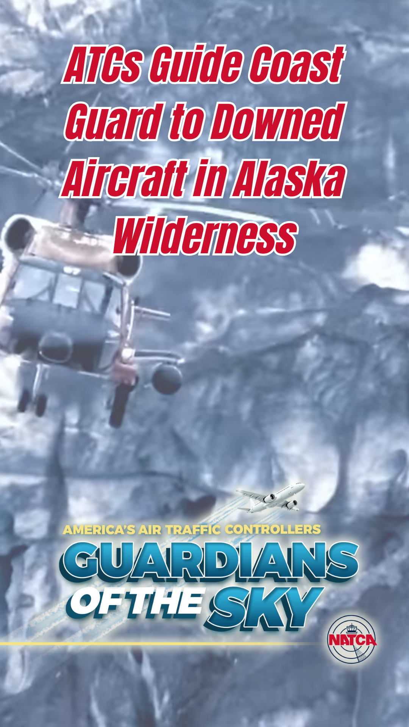

Website tags: Archie League Medal of Safety Awards, Guardians of the Sky, TikTok

**************************************************

8. NATCA: It’s Past Time to Modernize Air Traffic Control Facilities
Content for NATCA email, Facebook, LinkedIn, Instagram:

Nearly 40% of ATC facilities are over 50 years old — some even date back to the 1950s.
These outdated, deteriorating facilities weren’t built for the demands of modern aviation. Controllers shouldn’t have to deal with leaking roofs, malfunctioning heating and cooling, and broken elevators.
NATCA supports DOT Secretary Sean Duffy’s plan to modernize FAA facilities — but it will only happen if Congress fully funds it.
#Unions #Labor #LaborUnions #UnionStrong #aviation #ATC #NATCAStrong #AirTrafficControllers #NATCA #NATCAproud #weguideyouhome #strongertogether #solidarity

Content for NATCA website:
Behind every safe takeoff and landing in the United States are dedicated air traffic controllers working around the clock. But many of the facilities they work in are crumbling.
Nearly 40% of air traffic control facilities are more than 50 years old — some were built in the 1950s and 1960s. These aging buildings were never designed to meet the needs of today’s complex and high-volume aviation system.
Controllers are working in facilities with:
- Leaking roofs
- Broken elevators
- Failing heating and air conditioning systems
- Backed-up plumbing

This isn’t just inconvenient — it’s a threat to safety, efficiency, and the well-being of the professionals who manage our national airspace.
The National Air Traffic Controllers Association (NATCA) strongly supports DOT Secretary Sean Duffy’s plan to modernize FAA facilities across the country. These upgrades are essential to meet today’s demands and prepare for tomorrow’s challenges.
But to make this vision a reality, Congress must fully fund the plan.
Let’s give America’s air traffic controllers — and America’s flying public — a system we can all be proud of.
Short Form for Twitter:
40% of America’s ATC facilities are 50+ years old. Leaky roofs. Broken elevators. Failing HVAC. NATCA backs @SecDuffy’s plan to modernize — but Congress must fund it. <link to full story on natca.org, content above>
Caption for TikTok, YouTube:

40% of ATC facilities are 50+ years old. Leaking roofs. Broken elevators. Failing infrastructure. It’s time to modernize. NATCA supports Secretary Sean Duffy’s plan. Congress – fully fund the future of the National Airspace System.

#aviation #flying #airplanes #ATC #ATCOS #AirTrafficControllers #NATCA #weguideyouhome #solidarity #Unions #Labor #LaborUnions #UnionStrong #fyp #federalworkers

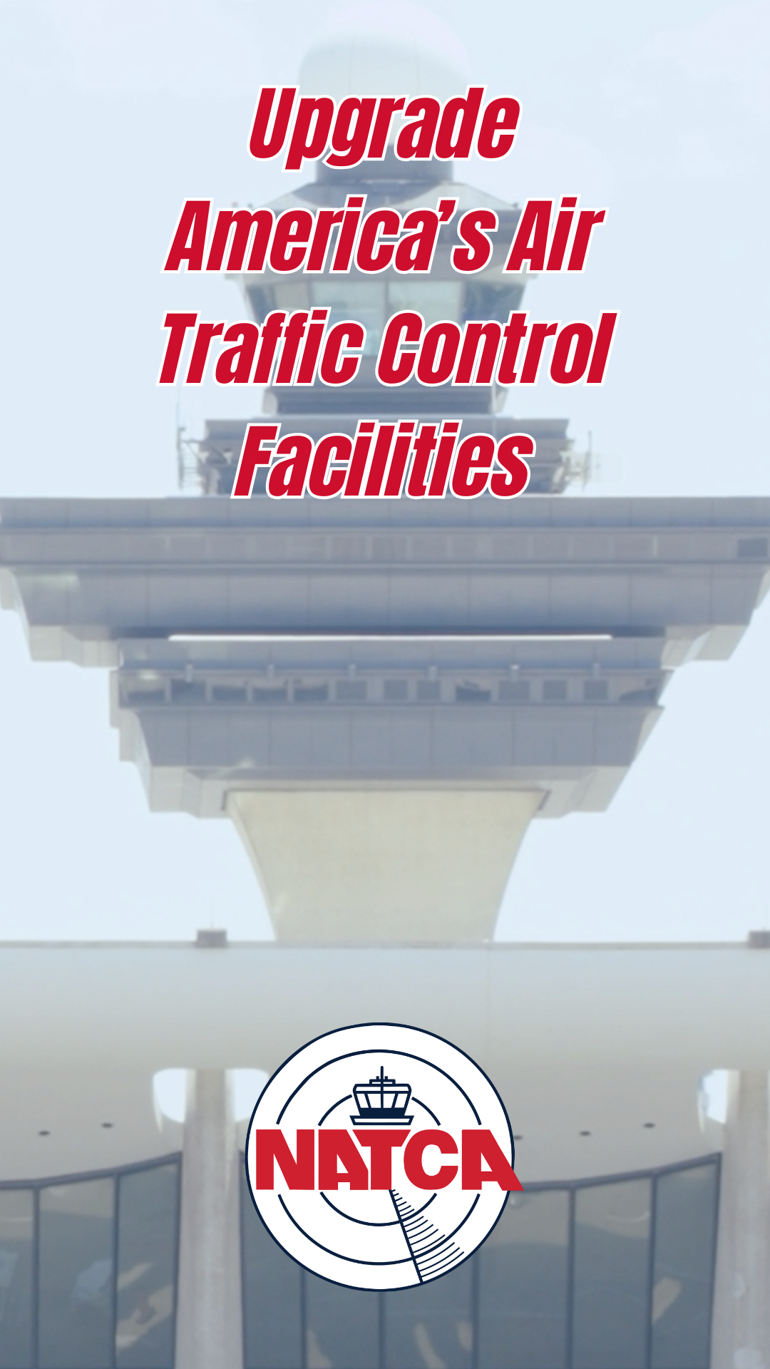

Website tags: Modernization, TikTok

**************************************************

9. Denver TRACON Controllers Helps Southwest Plane With Missing Engine Cowling Land Safely in NATCA’s Newest “Guardians of the Sky” Video

Content for NATCA email, Facebook, LinkedIn, Instagram:

When a Southwest Airlines flight experienced a problem with their engine upon takeoff from Denver International Airport, air traffic controllers sprung into action. A Denver TRACON controller immediately worked to clear the runway and coordinate with Denver ATCT for emergency vehicles.

#Unions #Labor #LaborUnions #UnionStrong #aviation #ATC #NATCAStrong #AirTrafficControllers #NATCA #NATCAproud #weguideyouhome #strongertogether #solidarity

Content for NATCA website:

NATCA is launching a new video series called “Guardians of the Sky.” Each video highlights a real-life incident where America’s air traffic controllers exemplified their skill, training, and professionalism in a moment of crisis.

Controllers do amazing work every day to ensure flying remains one of the safest and most efficient modes of transportation in the world. Guardians of the Sky emphasizes our dedication to this profession and the responsibility we have to the flying public.

When a Southwest Airlines flight experienced a problem with their engine upon takeoff from Denver International Airport, air traffic controllers sprung into action. A Denver TRACON controller immediately worked to clear the runway and coordinate with Denver ATCT for emergency vehicles.

Watch the video here: <link to Reel>

Short Form for Twitter:

NATCA is now on Tiktok! Follow us @natcanational. Our latest video highlights a controller who guided a Southwest Airlines flight to a safe landing after their engine cowling came off. <link to full story on natca.org, content above>

Caption for TikTok, YouTube:

When a Southwest Airlines flight experienced a problem with their engine upon takeoff from Denver International Airport, air traffic controllers sprung into action. A Denver TRACON controller immediately worked to clear the runway and coordinate with Denver ATCT for emergency vehicles.

Air traffic controllers do amazing work every day to ensure flying remains one of the safest and most efficient modes of transportation in the world. These Guardians of the Sky videos emphasize the dedication of these incredibly well-trained, hard-working men and women and the responsibility they demonstrate every day to the safety of the American flying public.

#aviation #flying #airplanes #ATC #ATCOS #AirTrafficControllers #NATCA #weguideyouhome #solidarity #Unions #Labor #LaborUnions #UnionStrong #fyp #federalworkers

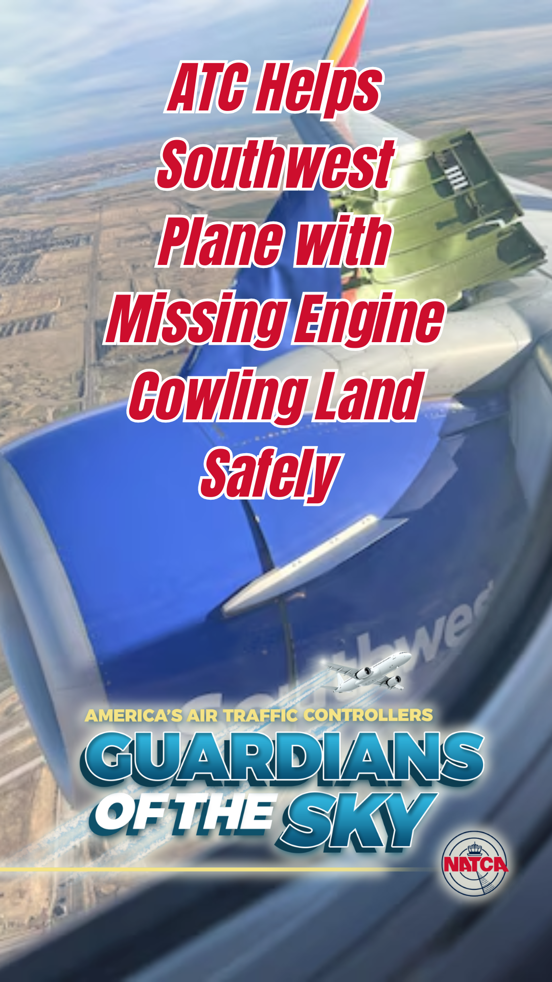

Website tags: Archie League Medal of Safety Awards, Guardians of the Sky, TikTok

**************************************************

10. Fort Worth Center Controllers Guide Plane With Low Fuel to Safety Despite Severe Oklahoma Storms in NATCA’s Newest “Guardians of the Sky” Video

Content for NATCA email, Facebook, LinkedIn, Instagram:

NATCA is now on Tiktok! Follow us @natcanational. Our latest video spotlights the work of two air traffic controllers at Fort Worth Center (ZFW) who helped the pilot of a small plane who could not land at his originally planned airport because of severe Oklahoma storms. The pilot needed to find an alternative airport quickly, because he only had 50 minutes of fuel remaining. The controllers coordinated with Fort Sill to allow the pilot to fly through their restricted airspace, so he could land at another airport safely before he ran out of fuel.

#Unions #Labor #LaborUnions #UnionStrong #aviation #ATC #NATCAStrong #AirTrafficControllers #NATCA #NATCAproud #weguideyouhome #strongertogether #solidarity

Content for NATCA website:

NATCA is launching a new video series called “Guardians of the Sky.” Each video highlights a real-life incident where America’s air traffic controllers exemplified their skill, training, and professionalism in a moment of crisis.

Controllers do amazing work every day to ensure flying remains one of the safest and most efficient modes of transportation in the world. Guardians of the Sky emphasizes our dedication to this profession and the responsibility we have to the safety of the American flying public.

When the pilot of a small plane cannot land at his originally planned airport because of severe Oklahoma storms and needs to find an alternative airport quickly, because he only has 50 minutes of fuel remaining, two controllers at Fort Worth Center (ZFW) coordinated with controllers at Fort Sill to allow the pilot to fly through their restricted airspace, so he could land at another airport safely before he ran out of fuel.

Watch the video here: <link to Reel>

Short Form for Twitter:

NATCA is now on Tiktok! Follow us @natcanational. Our latest video highlights controllers who helped a pilot of a small plane with low fuel find a safe place to land in severe Oklahoma storms. <link to full story on natca.org, content above>

Caption for TikTok, YouTube:

When the pilot of a small plane cannot land at his originally planned airport because of severe Oklahoma storms and needs to find an alternative airport quickly, because he only has 50 minutes of fuel remaining, two controllers at Fort Worth Center (ZFW) coordinated with controllers at Fort Sill to allow the pilot to fly through their restricted airspace, so he could land at another airport safely before he ran out of fuel.

Air traffic controllers do amazing work every day to ensure flying remains one of the safest and most efficient modes of transportation in the world. These Guardians of the Sky videos emphasize the dedication of these incredibly well-trained, hard-working men and women and the responsibility they demonstrate every day to the safety of the American flying public.

#aviation #flying #airplanes #ATC #ATCOS #AirTrafficControllers #NATCA #weguideyouhome #solidarity #Unions #Labor #LaborUnions #UnionStrong #fyp #federalworkers

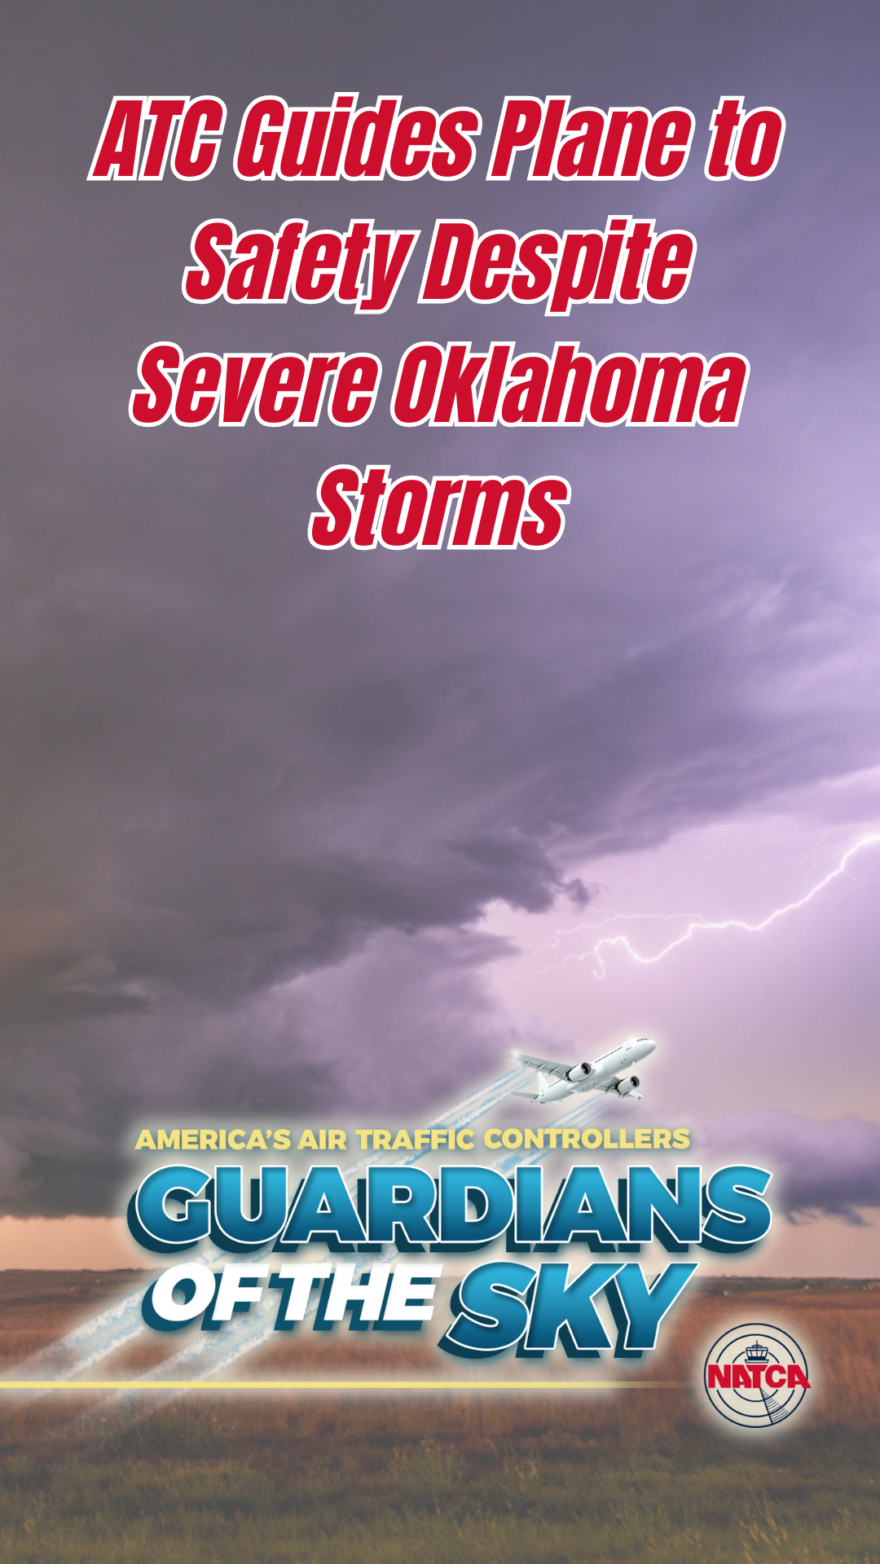

Website tags: Archie League Medal of Safety Awards, Guardians of the Sky, TikTok

**************************************************

